WISCONSIN SEA GRANT Name: _________________

Explore the Caddisfly go.wisc.edu/89z9gt
credits
Answer before you watch the video: Answer these after you watch the video:
Something I WONDER about the caddisfly | Something I NOTICED about the caddisfly | It REMINDS me of

FIELD NOTES
As you watch the video, jot down observations (what you notice) and new facts about the caddisfly in the spaces below.

Helpful Vocabulary
adaptation: modification of an organism or its parts that makes it more fit for living under the conditions of its environment; a heritable physical or behavioral trait that serves a specific function and improves an organism's fitness or survival

community: all the living things existing in the same place at the same time

dichotomous key: a resource used to identify a species using characteristics and differences between similar species

ecosystem: the communities of living and nonliving things interacting in the same space

habitat: where an individual organism exists

hatch: group of young born at the same time in the same place

macroinvertebrate: any animal lacking a backbone and large enough to see without the aid of a microscope. Macroinvertebrates are exothermic (or cold-blooded) and may be aquatic or terrestrial.

substrate: the base on which an organism lives

Field Notes: A Protective Case
An unusual thing about the caddisfly is its ability to create a protective case for shelter and protection, using items found in its habitat. Draw a caddisfly in its case.

Personalize It: A Protective Case
Draw or describe (in scientific narrative or in poetry) your own ideal protective case for shelter, using whatever you find or see in your habitat.

Field Notes from the Video
1. The Wisconsin Department of Natural Resources scientist talks about ways the case protects the caddisfly. Describe how this adaptation protects it.

2. The presence of a caddisfly is a sign of good water quality. What is your theory on why that is true?

3. How do juvenile and adult caddisflies differ? You may wish to consult the photographs of the caddisfly included in this packet or read a trusted online resource. Some online resources are included in the Learn More section.

More to Explore at Home
Expand your field notes with some research.

1. All living things play a role in their ecosystem. Using what you know about caddisflies and other similar species, what roles do caddisflies likely take on in their habitats?

2. We learned that the caddisfly builds a protective case to ward off predators. Research predator/prey relationships in a stream.

3. What do you predict might happen to caddisflies’ aquatic habitat if their numbers declined? (It might be helpful to think about your answer to the previous questions to get you started.)

4. What are the different life stages of the caddisfly? What factors are characteristic of these phases?

5. Anglers (people that love fishing) often create flies for their fishing poles that mimic caddisflies to help them catch trout. Brainstorm ways the natural world inspires you. Are there other ways you see humans mimicking nature?

6. Research macroinvertebrate life in a stream. Draw the community found there, taking care to include arrows to show how energy moves though the ecosystem.

7. Construct your own protective shelter using whatever you find around the house or outside.

8. Teach others about caddisflies! Make a poster or an online presentation about what you have learned and share it with others.

More to Explore Outside
1. Caddisflies have developed protective cases to survive in their habitats. Take a walk and make a list of the different plants and animals you see and the ways that they have adapted to survive and thrive.

2. Trout anglers make fishing flies to look like caddisflies. Create your own caddisfly-fishing fly using whatever supplies you have at home or find outside!

3. Practice being a scientist! Look for caddisflies in your local streams. Take note of the caddisflies’ characteristics, development stage, species of caddisfly. Note other features that may influence the caddisfly, such as
- the presence of any fish,
- the vegetative stage of the habitat (early spring, late spring, summer, fall, etc.)
- and abiotic (nonliving) factors in the caddisfly ecosystem (weather, water temperature, stream flow speed, time of day, etc.).

4. Sweep a net through pools, aquatic plants or rocky areas to try to catch what is living in the stream. Place the organisms in a bucket or wash tub to look at the behaviors that the insects and other species show. Pick up rocks and see if there are any insects or other species attached to them (but be sure to put the rocks back the way you found them). You can identify what you find with this dichotomous key of river organisms
http://clean-water.uwex.edu/pubs/pdf/riverkey.pdf

5. Leaf packs consist of a mesh bag with dead leaves in it that is anchored on the bottom in a pond, lake, stream or river. Order a leaf pack from a science supply company or build your own. Any plastic mesh bag with larger holes will work. A reusable produce bag with a drawstring can work for many deployments but you might need to add some larger holes. Keep the bag in the water for about a month. Then take it out of the water, dump the leaves in a washtub, and identify the insect species. Use the dichotomous key in activity 4 to identify what you see.
The species feed on the leaves and the other species that move into the pack.

Trichoptera Caddisfly (Adult)

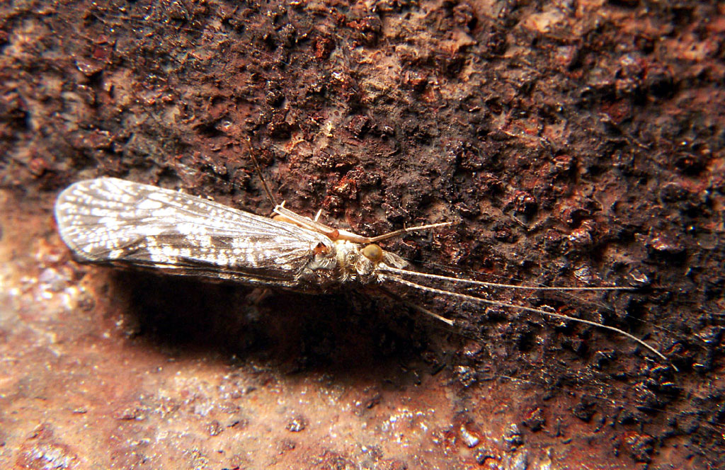

Photo: Bruce Marlin (CC BY-SA)

Trichoptera Caddisfly (Juvenile)
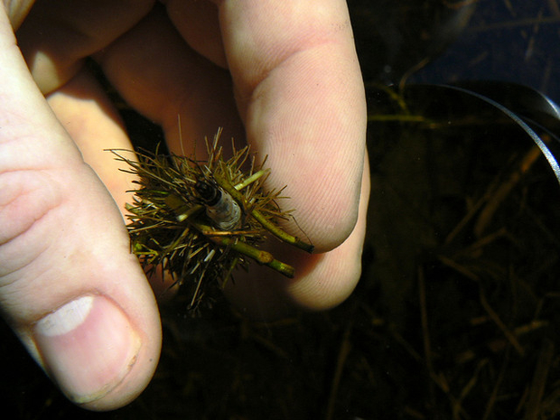
Photo: Benny Mazur (CC-BY)

Learn More
About the Caddisfly (University of Wisconsin-Milwaukee)
https://uwm.edu/field-station/caddisfly/

Aquatic Insects
https://www.rmbel.info/wp-content/uploads/2015/02/AquaticInsects-childrensguide.pdf

Tool for aquatic insect identification to support activities for citizen science
https://Macroinvertebrates.org

Found an aquatic insect, not sure what it is? Try this this pond dichotomous key
https://www.eekwi.org/explore/identification/water-critter-key-life-pond
Wonderful, Wacky Water Critters
https://cdn.shopify.com/s/files/1/0145/8808/4272/files/GWQ023.pdf

Preserve and protect your local streams. Volunteer and learn more about these aquatic ecosystems with Water Action Volunteers https://wateractionvolunteers.org/

Join teachers, students and citizen monitors from around the globe in freshwater research and stewardship with the Leaf Pack Network https://leafpacknetwork.org/

