WISCONSIN SEA GRANT

Explore the Burbot go.wisc.edu/nn387b

credits
Answer these before the presentation... |  | Answer this after you watch...
Something I have already NOTICED about the burbot…. | Something I WONDER about... | This video REMINDED me of….

FIELD NOTES
As you watch the video, jot down observations (what you notice) and new facts in the
space below.

LABEL THE DIFFERENT PARTS OF A BURBOT

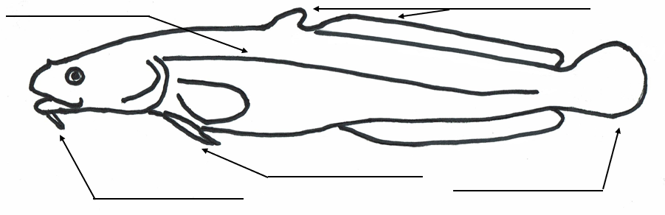

HELPFUL VOCABULARY  barbel: A whisker-like organ near the mouth or snout of a fish that is used to sense the presence of food or other objects.  benthic: Of, relating to, or occurring at the bottom of a body of water.  bottom feeder: A species that mainly feeds near the bottom of a lake or river in or near the sediment. The bottom of a lake or river is called the benthic zone.  diet study: Researching the food that a fish eats to better understand their ecology and how they respond to changes in the food we.  lateral line: Specialized scales on the side of the fish that can detect movement and vibrations.”  pelvic fin: A pair of fins on the underside of a fish. | FIELD NOTES continued  True or False? Burbot are a member of the cod family.  What time of year do burbot spawn?  How does a burbot find food?  What does a burbot eat?  True or False? Burbot have scales.

CONTINUE TO EXPLORE

• What challenges do burbot face? Research and create a call to action poster.
• Burbot live in other parts of North America. Research it and make a burbot range map.
• Learn what other fish species live in the deep waters of the Great Lakes.
• Look for recipes that use burbot (or other Great Lakes species) and try them out.

October 2020

