WISCONSIN SEA GRANT

Explore Lake Sturgeon go.wisc.edu/5g4c4_{e}
credits
Answer these before you watch the video... |  | Answer this after you watch...
Something I already KNOW about Lake Sturgeon | Something I am CURIOUS about and want to know | The most interesting fact  I LEARNED

FIELD NOTES
As you watch the video, jot down observations (what you notice) and new facts in the spaces below.

Label the different parts of a lake sturgeon

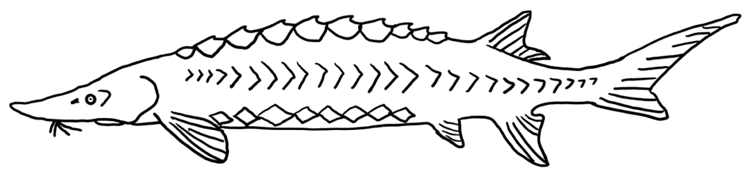

Field Notes
True or False: Sturgeon are prehistoric; they have been around since the time of the dinosaurs.

At what age does a female sturgeon reach maturity? A male?

How does a lake sturgeon find food?

What does a lake sturgeon eat?

What is another name for a person that studies sturgeon?

True or false: Sturgeon have scales.

Helpful vocabulary
barbel: A whisker-like organ near the mouth or snout of a fish that is used to sense the presence of food or other objects.
benthic: Of, relating to, or occurring at the bottom of a body of water.
bottom feeder: A species that mainly feeds near the bottom of a lake or river in or near the sediment. The bottom of a lake or river is called the benthic zone.
ichthyologist: A scientist who studies fish.
pelvic girdle: A structure made of cartilage that connects the two pelvic fins.
scutes: Sharp bony structures on the outside of sturgeon that help protect them from predators when they are small. When sturgeon are older and larger and cannot be easily eaten by predators, the scutes remain but are no longer sharp.
vent: A combined opening where both digestive waste (poop) and reproductive materials (eggs or sperm) are expelled.
Continue to explore

• What challenges do lake sturgeon face? Research and create a call to action poster.

• Lake sturgeon live in other parts of the world. Research it and make a global sturgeon map.

• Research the relationship between First Nations and sturgeon and create a piece of artwork that represents the connection between humans and sturgeon.

• When sturgeon begin spawning, sturgeon cams will begin livestreaming. (cityofshawano.com/412/ Sturgeon-Cam and wolfrivercam.com) Watch and make observations. Draw the sturgeon in their habitat and describe what you notice about their behavior.

April 2020

